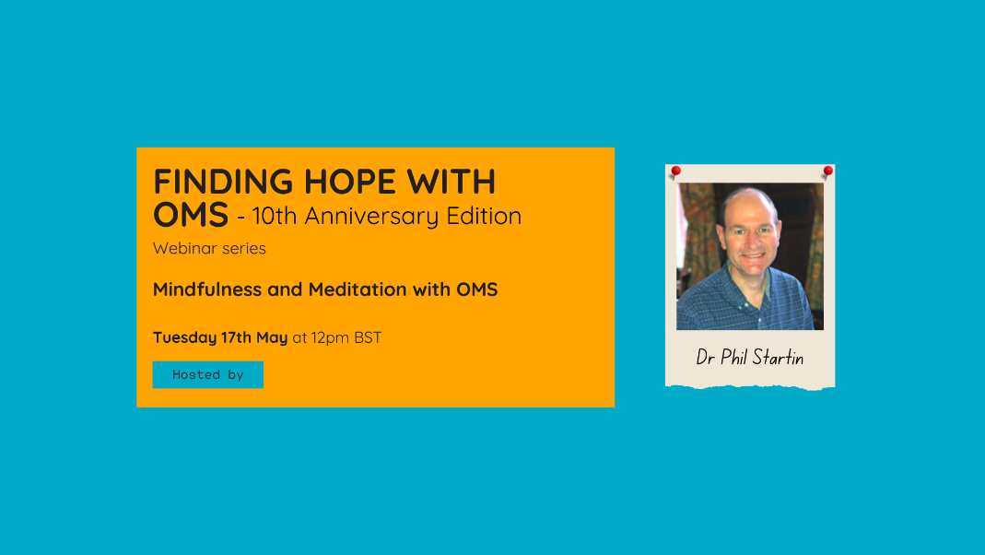

Books

Meditation:
- Jon Kabat-Zinn (1990), Full catastrophe living: Using the wisdom of your body and mind to face stress, pain and illness, New York: Delacorte; A book on how to meditate based on the pioneering 8 week Mindfulness Stress Based Reduction programme.
- Vajradevi (2021), Uncontrived mindfulness, Windhorse; Very insightful book on mindfulness meditation based on author’s deep personal experience of practice and mentoring from some of the world’s leading mindfulness practitioners.
- Anna Wise (20020, Awakening you mind; A different perspective on m editation, based on frequencies within the brain. And some very nice visualisation practices.
- Jon Kabat-Zinn (1994), Wherever you go, there you are, Piatkus; A collection of short pieces by Jon Kabat-Zinn that give guidance on meditation practice and incorporating mindfulness into everyday life.
- Bob Stahl and Elisha Goldsein (2010), A mindfulness based stress reduction workbook, New Harbinger Publications; A very accessible and well written workbook for the MBSR course. Includes a CD of some good guided meditations.

Mindfulness and neuroplasticity:
- Daniel Goleman and Richard Davidson, (2017), The Science of meditation; Easily readable book on the effects of meditation on the brqin
- Daniel Siegal (2010) , Mindful Sight , Oneworld; Insights into how the brain can change – and how we can make it happen

Others:
- Elizabeth Blackburn, Elissa Epel (2017), The Telomere Effect, Orion Spring; Excellent book by the Nobel prize winning scientist who discovered telomeres, with lots of references to how mindfulness, and other life choices, can lengthen telomeres.
- Rick Hanson (2013), Hardwiring happiness, Rider; Nice book using mindfulness to change the brain and increase happiness
- Ray Owen (2014), Living with the enemy, Routledge; Excellent book on acceptance and commitment therapy. Nice section on values and goals.
- Ed Mark Williams & Jon Kabat-Zinn (2013), Mindfulness – Diverse perspectives , Routledge; Academic articles on mindfulness published by renowned experts in the field of Buddhism and scientific research
- Sheng-Yen (2001), Hoofprint of the Ox, Oxford; Book written by a Chan Buddhist master giving Buddhist insights into meditation practicalities and the Buddhist framework
- Robert Gethin (1998), The Foundations of Buddhism, Oxford; Widely acclaimed book giving overview of Buddhism

Free guided meditations

Lots of guided meditations on the OMS website | https://overcomingms.org/resources/guided-meditation
Guided meditations from the Mindfulness Centre at Bangor University | https://www.bangor.ac.uk/mindfulness/audio/index.php.en
Guided mediations from Mindful magazine | https://soundcloud.com/mindfulmagazine
Various meditations from the London Insight Centre. | http://www.londoninsight.org/resources/audio-downloads/
The UCLA Mindful Awareness Research Center has a web page of free mindfulness mediations to download and try. | http://marc.ucla.edu/body.cfm?id=22
Nice collection of guided meditations | http://www.freemindfulness.org/download
Meditations to accompany the book “Mindfulness: Finding Peace in a Frantic World” | http://franticworld.com/free-meditations-from-mindfulness/
Good source of guided meditations | http://mindfulnessexercises.com/

Apps

There are lots of mindfulness apps that you can install on your phone, from basic timers to far more sophisticated apps that you pay for but include guided meditations (e.g. Headspace https://www.headspace.com/headspace-meditation-app ). The Insight Timer app is a nice free app with lots of guided meditations (https://insighttimer.com/ ).

Courses

Continental Europe
EAMBA accredits mindfulness teachers in continental Europe and you can find a teacher here: https://www.eamba.net/

UK
BAMBA provides a similar service in the UK: https://bamba.org.uk/

US
Brown University has a highly regarded mindfulness department and offers good courses: https://www.brown.edu/public-health/mindfulness/classes

